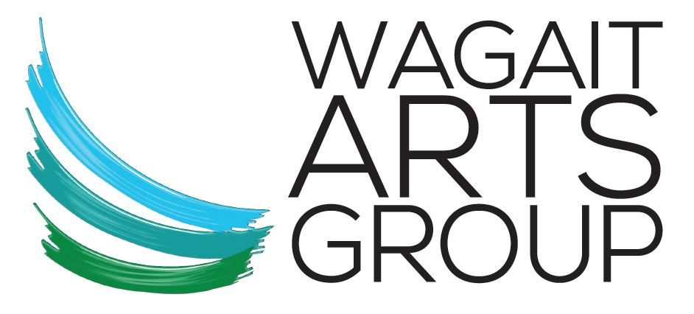

MEMBERSHIP APPLICATION FORM

The Wagait Arts Group Inc. (WAG) was established in 2013 and is a non-profit association. WAG grew out of a desire to showcase and support local arts from the communities of the Cox Peninsula. WAG offers artists a space to exhibit at an annual members’ event, promotion of regional arts; development of arts through workshops and other opportunities; and developing dialogue with the local, national and international arts community. Your WAG membership is an opportunity to be part of a dynamic local network of people supporting local arts.

Membership renewal is due 1st January and valid to 31st December. Individual/Family membership is $10 per year. Group membership is $20 per year. Membership helps contribute to Art Prizes and member events.

Benefits of membership include:
- Automatic free entry in the Members Exhibition
- Free/reduced entry fee to WAG art workshops

Name ................................................................... New member/renewal

Email Phone

Are you a Cox Peninsula resident?

If not resident, please tell us your connection to the Cox Peninsula ...........................................................

What art forms are you interested in? ......................................................................................

Would you be interested in volunteering at special events? ................................................................

Membership payment options:
- Direct Deposit:
Acct Name: Wagait Arts Group
BSB: 633 000
Acct Number: 167453612
Your name & WAG membership
- form and cash to – Carolyn McLennan

